Name: Nebojša Jotović
E-mail: nebojsa.jotovic@elfak.ni.ac.rs
Institution: University of Nis, Faculty of Electronic Engineering
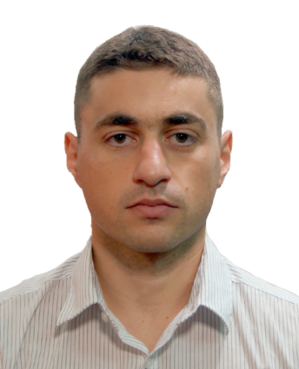 | Nebojša Jotović received the B.S. degree from the Faculty of Electronic Engineering, University of Niš, Republic of Serbia, in 2012. He currently works as a Science Research Associate at the Department of Control Systems at the Faculty of Electronic Engineering. He is a highly skilled IT professional with experience in maintaining computer laboratory equipment, as well as Web and graphic design.
References (max. 5 relevant references)
1. Marko T. Milojković, Dragan S. Antić, Darko B. Mitić, Nebojša S. Jotović, StanišaLj. Perić, “Doprino srazvoju društva znanja u Srbiji kroz realizaciju IPA projekta ADRIA HUB”, zbornikradova 58. konferencije ETRAN 2014, Vrnjačka Banja, Serbia, June 02.-05., 2014, pp. AU2.7.1-3, (ISBN: 978-86-80509-70-9), Publisher: Društvoza ETRAN. (M63)
2. Darko Mitić, Nenad D. Pavlović, Dragan Antić, Dejan Mitić, Nebojša Jotović: ,,Prikaz LiReX platforme", Zbornik radova 59. konferencije ETRAN 2015, Srebrno jezero, Srbija, Jun 08-11, 2015, str. AU2.7-1-4, Izdavač: Društvo za ETRAN, Srbija. (M63)
3. Nadežda Stojković, Nataša Bakić-Mirić, Aleksandra Nikčević-Batričević and Nebojša Jotović , “The hidden Content in the Syllabus of English for Specific Purposes: Issues of Culture and Globalization” in Vistas of English for Specific PurposesISBN-13: 978-1-4438-7635-3, pp. 255-262, Cambridge Scholars Publishing , 2015
4. Nebojša Jotović , “Modeliranje i Simulacija Inverznog Klatna Korišćenjem LQ i Fazi Regulatora” zbornik radova 4th IEEESTEC Student project conference (2011), Niš, Serbia, 30. November 2011,
This project has been funded with support from the European Commission. This publication reflects the views only of the author, and the Commission cannot be held responsible for any use which may be made of the information contained therein.

